**LAB PROGRAM 6: Implement the non-parametric Locally Weighted Regression algorithm in order to fit data points. Select appropriate data set for your experiment and draw graphs.**

**import numpy as np**

**import matplotlib.pyplot as plt**

**from sklearn.datasets import fetch_openml**

**from sklearn.model_selection import train_test_split**

**from sklearn.preprocessing import StandardScaler**

**# Step 1: Load Boston Housing dataset**

**data = fetch_openml(name='boston', version=1, as_frame=True)**

**X = data.data[['RM']].values # Using 'RM' (Average rooms per dwelling) as feature**

**y = data.target.astype(float).values # Convert target to float**

**# Step 2: Split dataset into training and testing sets**

**X_train, X_test, y_train, y_test = train_test_split(X, y, test_size=0.2, random_state=0)**

**# Step 3: Normalize data for better performance**

**scaler = StandardScaler()**

**X_train, X_test = scaler.fit_transform(X_train), scaler.transform(X_test) #calculates Mean and Std dev of X_train**

**# Step 4: Define Locally Weighted Regression function**

**def locally_weighted_regression(X, y, x_query, tau):**

**m = X.shape[0] #gets the number of training examples and X.shape[0] gives the number of rows**

**X_bias = np.c_[np.ones(m), X]** **# Add bias term**

**x_query_bias = np.r_[1, x_query]** **# Add bias term for query point**

**# Compute weights using Gaussian Kernel (Eq. 4.4)**

**W = np.diag(np.exp(-np.square(X - x_query) / (2 * tau**2)).flatten())**

**# Solve weighted least squares: θ = (X'WX)^(-1) X'Wy**

**theta = np.linalg.pinv(X_bias.T @ W @ X_bias) @ (X_bias.T @ W @ y)**

**return x_query_bias @ theta** **# Prediction**

**# Step 5: Compute LWR predictions**

**tau = 0.4 # Bandwidth parameter**

**y_pred = np.array([locally_weighted_regression(X_train, y_train, x_q, tau) for x_q in X_test])**

**# Step 6: Plot results**

**plt.figure(figsize=(14, 6))**

**# Subplot 1: Scatter plot for LWR results**

**plt.subplot(1, 2, 1)**

**plt.scatter(X_train, y_train, label='Training Data', color='blue', alpha=0.5)**

**plt.scatter(X_test, y_test, label='Test Data', color='green', alpha=0.5)**

**plt.scatter(X_test, y_pred, color='red', label='LWR Predictions', alpha=0.7)**

**plt.xlabel('Average Rooms per Dwelling (Normalized)')**

**plt.ylabel('House Price')**

**plt.title('Locally Weighted Regression on Boston Housing Data')**

**plt.legend()**

**# Subplot 2: Scatter plot for Predicted vs Actual Plot**

**plt.subplot(1, 2, 2)**

**plt.scatter(y_test, y_pred, color='blue', alpha=0.7)**

**plt.plot([min(y_test), max(y_test)], [min(y_test), max(y_test)], color='red', linestyle='--', label='Ideal Fit')**

**plt.xlabel('Actual House Price')**

**plt.ylabel('Predicted House Price')**

**plt.title('Prediction vs Actual Plot for LWR')**

**plt.legend()**

**# Display both plots**

**plt.tight_layout()**

**plt.show()**

**OUTPUT:**

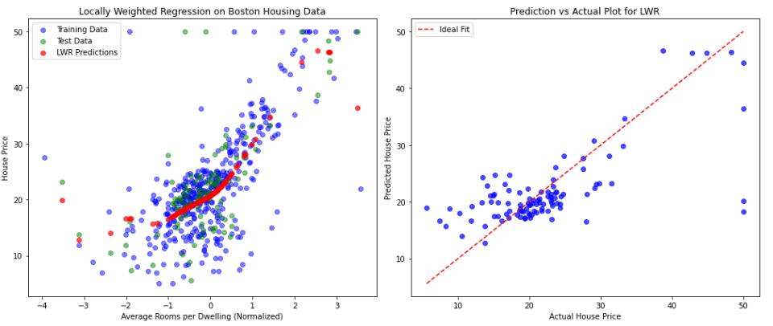

**Boston Housing Dataset**

| **Feature** | **Description** |
| --- | --- |
| **CRIM** | Per capita crime rate by town |
| **ZN** | Proportion of residential and zoned for large lots |
| **INDUS** | Proportion of non-retail business acres |
| **CHAS** | Charles River dummy variable (1 if tract bounds river; 0 otherwise) |
| **NOX** | Nitric oxide concentration (pollution) |
| **RM** | **Average number of rooms per dwelling** |
| **AGE** | Proportion of owner-occupied units built before 1940 |
| **DIS** | Weighted distances to employment centers |
| **RAD** | Index of accessibility to radial highways |
| **TAX** | Property tax rate |
| **PTRATIO** | Pupil-teacher ratio |
| **B** | Measure of African American population (deprecated feature) |
| **LSTAT** | % of lower status population |
| **MEDV** | **Median value of homes** **(target variable)** |

**LAB PROGRAM 7: Develop a program to demonstrate the working of Linear Regression and Polynomial Regression. Use Boston Housing Dataset for Linear Regression and Auto MPG Dataset (for vehicle fuel efficiency prediction) for Polynomial Regression.**

**import numpy as np**

**import pandas as pd**

**import matplotlib.pyplot as plt**

**import seaborn as sns # visualization library built on top of matplotlib**

**import warnings # To control warning messages**

**from sklearn.datasets import fetch_openml #loads datasets from openML-boston housing dataset**

**from sklearn.linear_model import LinearRegression**

**from sklearn.preprocessing import PolynomialFeatures**

**from sklearn.metrics import mean_squared_error, r2_score**

**from sklearn.model_selection import train_test_split**

**warnings.filterwarnings("ignore")** **#Suppresses warning messages**

**# -----------------------------**

**# Part 1: Linear Regression on Boston Housing**

**# -----------------------------**

**# Load Boston Housing dataset via OpenML**

**boston = fetch_openml(name="boston", version=1, as_frame=True)**

**X_boston = boston.data # all features**

**y_boston = boston.target # Median house price**

**# Split dataset**

**X_train_b, X_test_b, y_train_b, y_test_b = train_test_split(X_boston, y_boston, test_size=0.2, random_state=42)**

**# Train linear regression model**

**linear_model = LinearRegression() #Initializes a model**

**linear_model.fit(X_train_b, y_train_b) #Trains the model**

**y_pred_b = linear_model.predict(X_test_b) #Model used to predict for the test set**

**# Evaluate**

**print("----- Linear Regression: Boston Housing -----")**

**print(f"MSE:{mean_squared_error(y_test_b, y_pred_b):.2f}")** **# Calculate Mean Squared Error- measures prediction error**

**print(f"RMSE: {np.sqrt(mean_squared_error(y_test_b, y_pred_b)):.2f}") # Calculate Root Mean Squared Error (RMSE)**

**print(f"R² Score: {r2_score(y_test_b, y_pred_b):.2f}")** **# Calculate R-squared value- how well model explains variance91 is perfect)**

**print()**

**# -----------------------------**

**# Part 2: Polynomial Regression on Auto MPG**

**# -----------------------------**

**# Load Auto MPG dataset**

**df = sns.load_dataset('mpg') # Loads the auto MPG dataset using seaborn**

**df = df.dropna() # drops rows with missing values to prevent errors**

**df['horsepower'] = df['horsepower'].fillna(df['horsepower'].median())** **# hp-measure of an engine’s power**

**X_mpg = df[['horsepower']] # Selects horsepower as the feature**

**y_mpg = df['mpg'] # Selects Miles Per Gallon as the target**

**# Split dataset**

**X_train_m, X_test_m, y_train_m, y_test_m = train_test_split(X_mpg, y_mpg, test_size=0.2, random_state=42)**

**# Polynomial regression (degree 2)**

**poly = PolynomialFeatures(degree=2) #Quadratic equation**

**X_train_poly = poly.fit_transform(X_train_m) #Transforms training and test input into polynomial form**

**X_test_poly = poly.transform(X_test_m)**

**poly_model = LinearRegression()**

**poly_model.fit(X_train_poly, y_train_m)**

**y_pred_poly = poly_model.predict(X_test_poly)**

**# Evaluate**

**print("----- Polynomial Regression: Auto MPG (Degree 2) -----")**

**print(f"MSE:{mean_squared_error(y_test_m, y_pred_poly):.2f}")** **#Calculate Mean Squared Error**

**print(f"RMSE: {np.sqrt(mean_squared_error(y_test_m, y_pred_poly)):.2f}")** **# Calculate Root Mean Squared Error (RMSE)**

**print(f"R² Score: {r2_score(y_test_m, y_pred_poly):.2f}")** **# Calculate R-squared value**

**print()**

**# Plot Polynomial Regression results**

**X_range = np.linspace(X_mpg.min(), X_mpg.max(), 100).reshape(-1, 1) #creates 100 evenly spaced hp values within the range of the dataset and reshaped into 2D array to match model input format**

**X_range_poly = poly.transform(X_range) #Transforms into polynomial forms**

**y_range_pred = poly_model.predict(X_range_poly) #Predicts MPG for this range**

**plt.scatter(X_mpg, y_mpg, color='green', label='Actual Data')**

**plt.plot(X_range, y_range_pred, color='red', label='Polynomial Fit (Degree 2)', linewidth=2)**

**plt.xlabel("Horsepower")**

**plt.ylabel("MPG")**

**plt.title("Polynomial Regression: Horsepower vs MPG")**

**plt.legend()**

**plt.grid(True)**

**plt.show()**

### ****Auto MPG Dataset:****

The **Auto MPG (miles per gallon)** dataset was published by the UCI Machine Learning Repository. It's used to **predict fuel efficiency (MPG)** of cars based on various characteristics like weight, engine size, and horsepower.

| **Feature** | **Description** |
| --- | --- |
| **mpg** | **Target variable — miles per gallon (fuel efficiency)** |
| **cylinders** | Number of cylinders (e.g., 4, 6, 8) |
| **displacement** | Engine displacement (cubic inches) |
| **horsepower** | **Engine power** |
| **weight** | Vehicle weight |
| **acceleration** | Time to accelerate from 0 to 60 mph (in seconds) |
| **model year** | Year of the car (e.g., 70 = 1970) |
| **origin** | Region of origin (1 = USA, 2 = Europe, 3 = Asia) |
| **car name** | Name of the car (e.g., "chevrolet impala") |

**OUTPUT:**

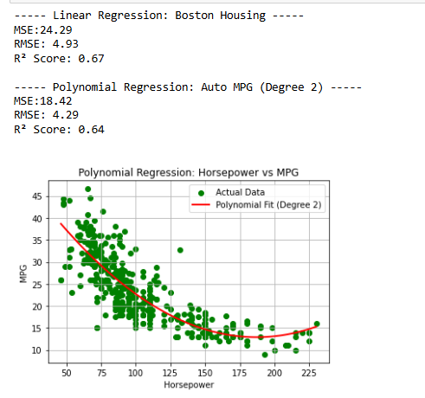

### ****1. Linear Regression: Boston Housing****

* **Dataset:** Boston Housing (predicting house prices based on features like crime rate, number of rooms, etc.)
* **MSE:** 24.29
  + The average squared difference between predicted and actual prices is 24.29 units².
* **RMSE:** 4.93
  + On average, the model’s predictions are off by about 4.93 units.
* **R² Score:** 0.67
  + The model explains **67% of the variance** in house prices, which is a decent fit.

### ****2. Polynomial Regression (Degree 2): Auto MPG****

* **Dataset:** Auto MPG (predicting fuel efficiency or MPG based on features like horsepower)
* **MSE:** 18.42
  + Lower than the Boston model, indicating smaller squared errors.
* **RMSE:** 4.29
  + Slightly better average prediction error than the linear model.
* **R² Score:** 0.64
  + Explains **64% of the variance** in MPG — slightly lower than the Boston model despite lower error values.

**Graph:**

* There’s a **non-linear inverse relationship** — as horsepower increases, MPG generally decreases.
* The quadratic curve fits this relationship better than a straight line would.
* The red curve flattens at high horsepower, capturing that MPG levels off at higher power levels.

